
Big Bang Day will be on 04/11/2025. The children will be immersed into the time period of Ancient Egypt by looking at the roles and hierarchy of the Ancient Egyptian community, explore hieroglyphics and collaborate to make a pyramid out of spaghetti and marshmallows.

History: This half term, children will explore life in Ancient Egypt, compare it to modern life, investigate Egyptian beliefs and artefacts, and engage in debates and creative projects to understand key historical concepts.

Year 4 – Autumn 2 – How did the landscape of Ancient Egypt influence their lifestyle and beliefs?

English: The focus this term will be creating a historical narrative based on Cinderella of the Nile, using creative writing and drama techniques to explore key themes and express character emotions.
Children will also write a discussion text, writing a series of points in favour or against the treatment of both Cinderella in the Disney film and Cinderella of the Nile, and will develop their own opinions through discussion and debate techniques.

Art/DT: This half term the children will be creating clay cartouches using moulding techniques and creating patterns that would be used by traditional Egyptians. Children will have an opportunity to research, practise and refine their final outcomes.
Examples:
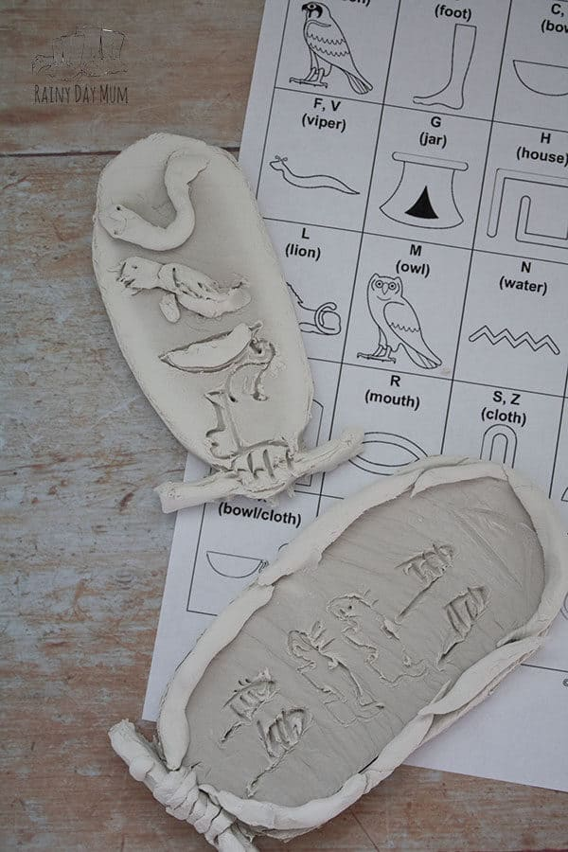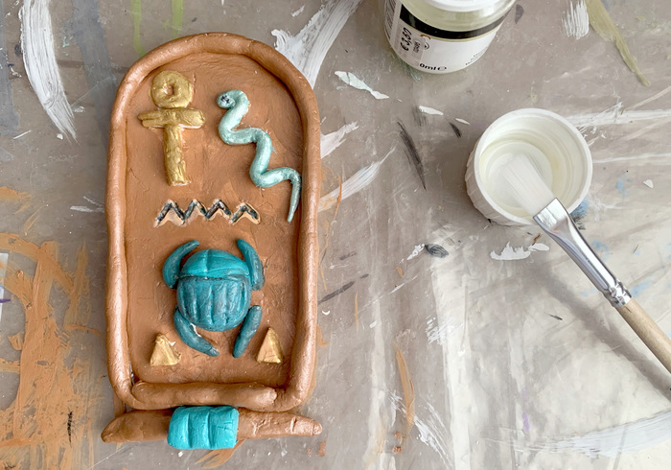

Computing: Children will review design principles, create presentations and app mock-ups using Keynote, apply transitions and animations, and present their work while reflecting on the design and feedback process.

Personal Development: Children will learn to differentiate between playful and hurtful behaviour, explore teamwork and communication, understand the impact of bullying, recognize diversity, and reflect on mutual respect, British values, and the importance of working collaboratively in various activities and discussions.

Physical Education: In PE this term, children will focus their learning on when and where to jump or duck to avoid the ball in Dodge Ball and in football to refine dribbling in order to keep control and possession of the ball.

Religious Education: During RE this half term, the focus will be to explore Hindu festivals, traditions, and beliefs, compare them with their own experiences, and make connections between Hinduism and other religions through creative activities, discussions, and reflections.

Trips: This term, the children will be enhancing their learning of Egyptians by visiting The British Museum. They will see and find out about the traditional way of life of Egyptians and their beliefs.

MFL: In MFL, the children will be learning the topic “Hobbies” in Spanish, using the Language Nut app to practise vocabulary and build simple sentences about hobbies.

Music: The children will be learning about ancient Egyptian music - what instruments they had, what they may have sounded like and how they compare to some modern-day instruments. They will then be revising chords on the ukulele and learning some songs about Ancient Egypt.

Maths: This term, children will be introduced to area for the first time and explore how the surface of shapes and objects can be measured in different ways. They will also come to understand the concept of multiplication and division. This will be done by using manipulatives, number lines, and grouping strategies to visualize multiplication and division.

Science: This term, children will explore how the human body processes food by learning about the main organs and functions of the digestive system. They will also investigate the different types of human teeth and their roles, comparing them with the teeth of various animals to understand how diet influences tooth shape and function.

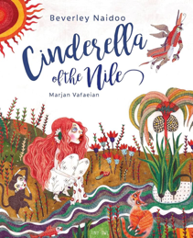
Core Text

